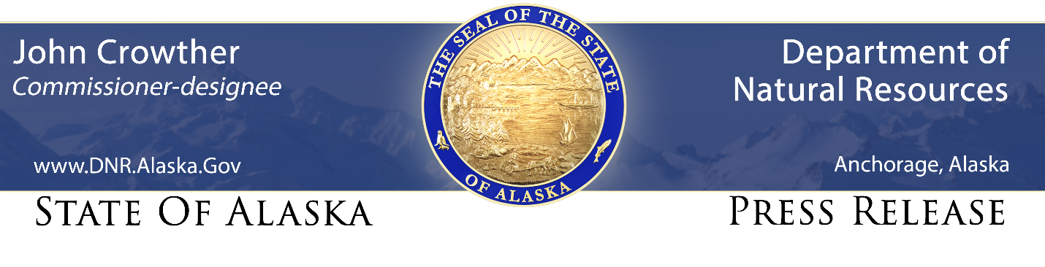
For Immediate Release: May 7, 2026

Annual Prescribed Burning Operations Start Soon

The Alaska Division of Forestry & Fire Protection (DFFP) is preparing for multiple prescribed burns in the Fairbanks, and Matanuska-Susitna Valley areas in the coming months. Burning operations can begin as early as May 8th, weather and conditions permitting.

The prescribed burns are planned for the following areas:

• Fairbanks: Creamer’s Field Migratory Waterfowl Refuge, in partnership with the Alaska Department of Fish & Game, as early as May 11th.

• Palmer: Near the end of Maud Road, at the Kenny and Patti Barber Shooting Range and at the Palmer Forestry Office, as early as May 8th.

• Sutton: Little Granite Creek area near Sutton/Chickaloon, in partnership with the Alaska Department of Fish & Game, as early as May 11th.

• Wasilla: At the end of W. Shirley Road off N. Sitze Road as early as May 8th.

Annual prescribed burns offer multiple benefits for the 2026 fire season. These controlled burns safely manage dry, grassy fuels and provide crucial training for firefighters as they prepare for the coming season. Additionally, they foster collaboration with partners to improve overall habitat management.
Further details on individual prescribed burns will be released as they become available. All planned operations are dependent on safe weather and fuel conditions. While public impact is expected to be minimal, smoke may be visible in the Fairbanks and Mat-Su areas during active burn periods. The Division of Forestry & Fire Protection is committed to developing, conserving, and maximizing the use of Alaska's natural resources in a way that aligns with the public interest.

Contact: Emery Johnson, 907-590-4038, emery.johnson@alaska.gov

###

STAY CONNECTED:
DNR Newsroom: http://dnr.alaska.gov/commis/dnr_newsroom.htm
DNR on Social Media: http://dnr.alaska.gov/commis/social_media.htm
DNR Public Information Center: http://dnr.alaska.gov/commis/pic/

